Social and Economic Impact Assessment of the RCA Programme

Non Destructive Testing

Table of Contents

###### Report Information

|  |  |
| --- | --- |
| Prepared for | International Atomic Energy Agency |
| Prepared by | Julian King, Kate McKegg, Andres Arau, Aaron Schiff, Martina Garcia Aisa |
| Cover image |  |
| Citation | King,J., McKegg, K., Arau, A., Schiff, A., Garcia Aisa, M. (2021). *Social and Economic Impact Assessment of the RCA Programme: Non Destructive Testing Case Study.* Vienna, Austria: International Atomic Energy Agency. |

## Disclaimer

Disclaimer: The information in this document is presented in good faith using the information available to us at the time of preparation. It is provided on the basis that the authors of the document are not liable to any person or organisation for any damage or loss which may occur in relation to taking or not taking action in respect of any information or advice within this document

## Acknowledgements

The authors are grateful for the close and effective assistance of the Technical Cooperation division for Asia-Pacific (TCAP) and Technical Cooperation Division of Programme Support and Coordination (TCPC) of the International Atomic Energy Agency (IAEA), and the experts from the X participating GPs in the X Regional Cooperative Agreement (RCA):

# Acronyms

|  |  |
| --- | --- |
| Name | Acronym |
| Asia Pacific Federation of NDT | APFNDT |
| Eddy Current System | ET |
| Government Party | GP |
| International Atomic Energy Agency | IAEA |
| International Commitee on Non-destructive Testing | ICNDT |
| Multilateral Recognition Agreement | MRA |
| Magnetic Particle Testing | MT |
| National Certification Body | NCB |
| Non Destructuve Testing | NDT |
| Liquid Penetrant Testing | PT |
| Quality Assurance | QA |
| Quality Control | QC |
|  | RCVA |
| Radiographic Testing Method | RT |
| Time of Fligth Diffraction | TOFD |
| Ultrasonic Testing | UT |

# Executive Summary

# Introduction

This report presents the findings of the Social and Economic Impact Assessment of Non Destructive Testing (NDT) of the RCA in Asia and the Pacific. The data to inform the analysis was collected through an online survey conducted between June and August 2021. The main respondents of the survey were national experts on the field of NDT whom provided relevant information about the equipment, training centres, certified personal, and health and safety impacts of the RCA programme in their country.

From the 22 countries that are part of the Cooperative Agreement for Research (RCA), 20 participated in the survey: Australia, Bangladesh, Cambodia, China, India, Indonesia, Japan, Laos, Malaysia, Mongolia, Myanmar, Nepal, New Zealand, Pakistan, Philippines, Singapore, South Korea, Sri Lanka, Thailand, and Vietnam.

Figure: 1 below shows the countries that participated in this study

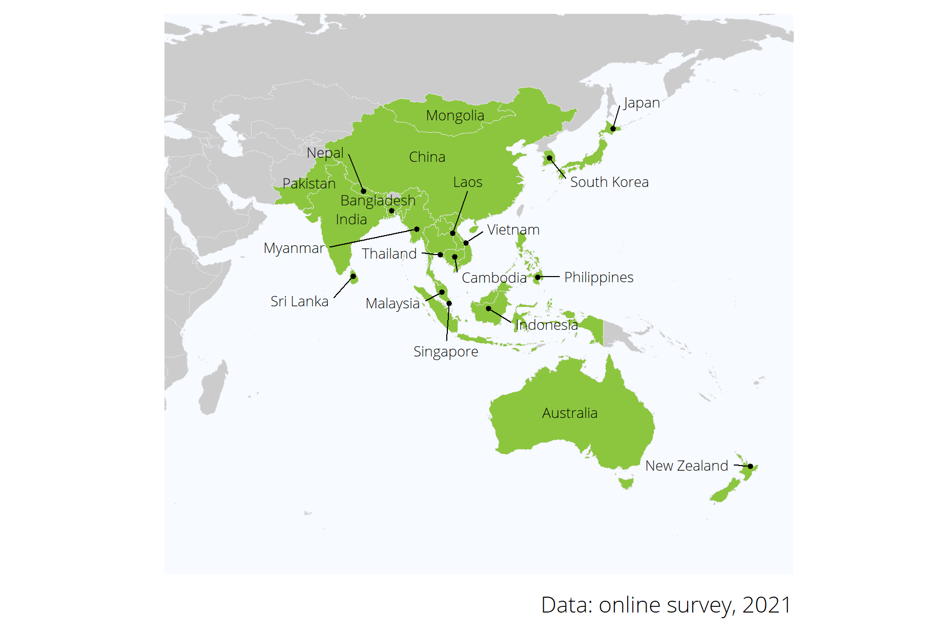

Figure 1: Map of the 20 countries that partipicated in the online survey.

## Non Destructive Testing

## Social and economic impact assessment methods

# Social and economic impacts

## Improved NDT capacity and capability

|  |  |
| --- | --- |
| **Standard applied to each GP** | **Criterion 1: Improved NDT capacity and capability** |
| **Excellent** (exceeding expectations)    GPs with excellent status meet the standard for Good, plus: | **GPs have fulfilled the MRA requirements of ICNDT** as a result of the support under the RCA programme of IAEA.   * NDT Society is registered with APFNDT and ICNDT * The society is a signatory to ICNDT MRA * NCB for NDT accredited to ISO 17024 * NCB accepted for registration under the ICNDT MRA * Accredited training centres offering ISO 9712 training.   The support in establishing GPs’ NDT infrastructure through the RCA programme has enabled **GPs to produce *certified personnel in advanced techniques (RT-D, PAUT, TOFD, PEC, etc)*, in addition to the conventional methods (RT, UT, MT, PT, ET).**  GPs have achieved increased self-reliance in NDT, including offering training and inspection activities to local industries as well as abroad. |
| **Good** (meeting expectations)  GPs with good status meet the standard for Adequate, plus: | **GPs have established internationally-recognised NDT infrastructure at the national leve**l as a result of the support under the RCA programme of IAEA.   * NDT Society has been established * National certification body on NDT has been established. * Local NDT training centres are offering ISO 9712 training   The support in establishing GPs’ NDT infrastructure through the RCA programme has enabled **GPs to produce certified personnel in all levels of NDTs’ *five main methods* (RT, UT, MT, PT, ET)** through the national NDT certification scheme.[^Since most national certification schemes started late compared to other certification, acceptance is the main challenge.]  GPs have local NDT training centres and inspection companies offering services to local industry. |
| **Adequate** (meeting bottom-line expectations) | GPs have established **basic NDT infrastructure at the national level** as a result of the support under the RCA programme of IAEA.  National certification scheme has been established and there are **certified personnel produced by the national NDT certification scheme, however, for limited method(s) and not for all 5 main methods.**  There are trained personnel at the GP organisation level.  GPs have training centres and inspection companies, owned by foreign entities. |
| **Inadequate** | The level of NDT infrastructure is below the standard for Adequate |

The aim of this section is to assess the extent to which **i) the Government Parties (GPs) have fulfilled the Multilateral Recognition Agreement (MRA) requirements** of the International Commitee on Non-destructive Testing (ICNDT) as a result of the support under the RCA programme of IAEA; **ii) The support in establishing GPs’ NDT infrastructure through the RCA has enabled GPs to produce certified personnel** in advanced techniques (RT-D, PAUT, TOFD, PEC, etc), in addition to the conventional methods (RT, UT, MT, PT, ET), and **iii) the GPs have achieved increased self-reliance in NDT**, including offering training and inspection activities to local industries as well as abroad.

This section presents the main findings in terms of Infrastructure, Inspection companies and training centres, and certified personnel.

## Infrastructure

For this evaluation, an excellent performance in terms of infrastructure is defined as the extent to which a GPs has fullfiled the MRA requirements of ICNDT and the status of the NDT infrastructure at the national level.

Figure 2 shows the level of NDT infrastructure that each GP has in its country and the evaluation standards for each: out of the 20 countries that participated in the online survey, only Nepal and Myanmar do not have established a National Certification Scheme yet; Almost all countries but Laos, Cambodia, Nepal, and Myanmar have registered their NDT society in the Asia Pacific Federation of NDT (APFNDT); and for 10 out of the 20 GPs, their NCB for NDT has been accredited to ISO 17024.

Based on the criterion developed by RCA to assess the performance of GPs in terms of infrastructure, Australia, China, Malaysia, Singapore, and South Korea have excellent standards on this dimension. (See criterion and standards in Annex X)

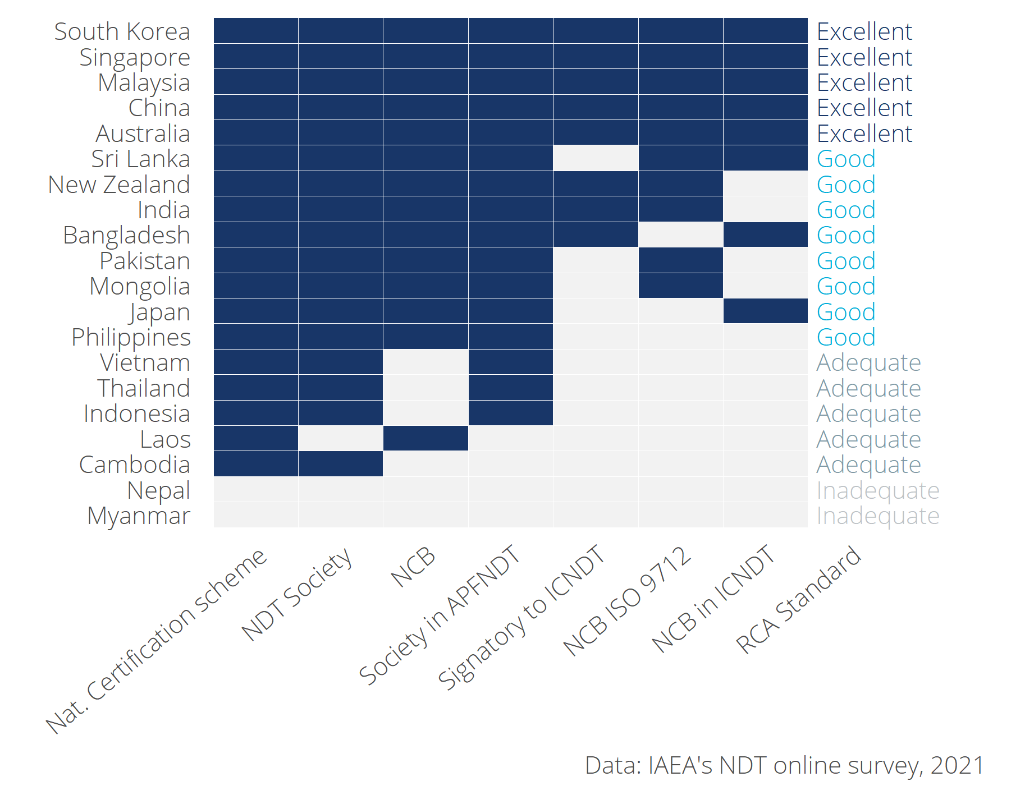

Figure 2: NDT infrastructure at the national level and assessment standards.

### Contribution of RCA in GP’s infrastructure

To asses the contribution of RCA in the stablishement of NCBs and Naitonal Certification Schemes, the participants of the online survey were asked the extent to which they believe that the RCA NDT programme has contributed to the establishment of this infrastructure in their countries.

As it can be seen in the Table 1, ten GPs **(Bangladesh, China, Laos, Malaysia, Mongolia, Pakistan, Philippines, Singapore, South Korea, and Sri Lanka) perceived that the RCA programme has contributed to a great extent in the establishment of their national NCB**. Only Australia, Japan, and New Zealand perceived that the establishment of their RCA could have been achieved without the support from the RCA programme.

Table 1: Contribution of RCA programme in GP’s infrastructure

|  |  |  |  |  |  |
| --- | --- | --- | --- | --- | --- |
| Country | Has NCB | RCA contribution to establish NCB | Has NDT certification scheme | RCA contribution to establish NDT certification scheme | RCA standard |
| Australia | Yes | Not at all | Yes | Not at all | Excellent |
| Bangladesh | Yes | To a great extent | Yes | To a great extent | Good |
| Cambodia | No |  | Yes | Not at all | Adequate |
| China | Yes | To a great extent | Yes | To a great extent | Excellent |
| India | Yes | Little | Yes | Little | Good |
| Indonesia | No |  | Yes | To a great extent | Adequate |
| Japan | Yes | Not at all | Yes | Not at all | Good |
| Laos | Yes | To a great extent | No |  | Adequate |
| Malaysia | Yes | To a great extent | Yes | To a great extent | Excellent |
| Mongolia | Yes | To a great extent | Yes | Little | Good |
| Myanmar | No |  | No |  | Inadequate |
| Nepal | No |  | No |  | Inadequate |
| New Zealand | Yes | Not at all | Yes | Not at all | Good |
| Pakistan | Yes | To a great extent | Yes | To a great extent | Good |
| Philippines | Yes | To a great extent | Yes | To a great extent | Good |
| Singapore | Yes | To a great extent | Yes | To a great extent | Excellent |
| South Korea | Yes | To a great extent | Yes | To a great extent | Excellent |
| Sri Lanka | Yes | To a great extent | Yes | To a great extent | Good |
| Thailand | No |  | Yes | Not at all | Adequate |
| Vietnam | No |  | Yes | To a great extent | Adequate |

## Inspection companies and training centers

Self reliance in NDT is a function of countries having the capacity to conduct inspection and train personnel without depending on external stakeholders. An assessment to map whether GPs have inspection and training centers owned locally or by foreigners was conducted to estimate the level of self-reliance that each GP has. According to the criterion developed, a GP is considered to have an excellent standard (or to have achieved increased self-reliance) if their local inspection and training centres offer their services abroad. On the other hand, the self-reliance of a GP is considered inadequate if it does not have both training and certification centres owned either by local or foreign firms.

As it can be seen in Figure 3 that displays the criterion and standards for this dimension. 6 countries (Australia, Malaysia, Pakistan, Singapore, South Korea, and Vietnam) offer both training and inspection abroad. Moreover, Myanmar and Nepal do have access to inspection centres (either owned locally or by foreigners) but they do not have training centres offering services in their countries.

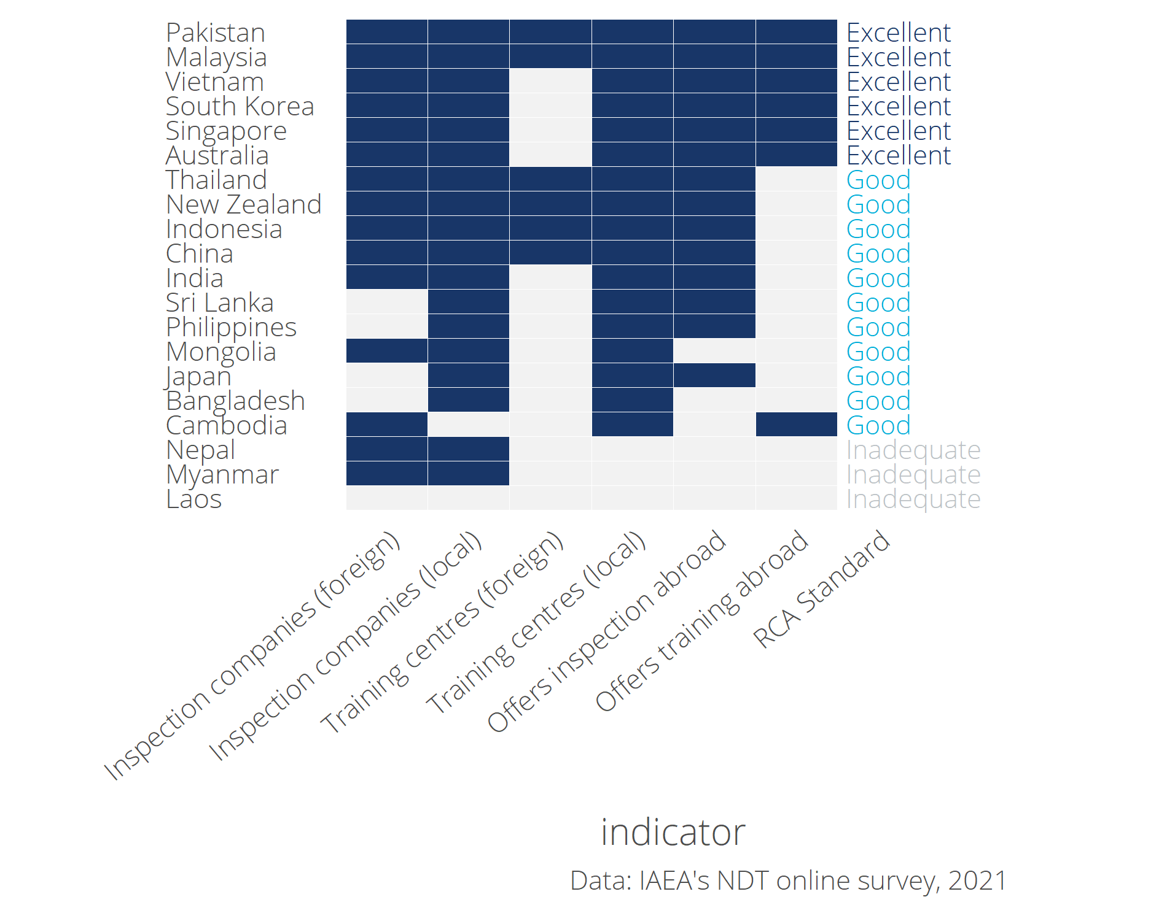

Figure 3: GP’s inspection and training centers: standards for self-reliance

Figure 4 below shows the number of **inspection centres** owned by local and foreign firms in each RCA country.

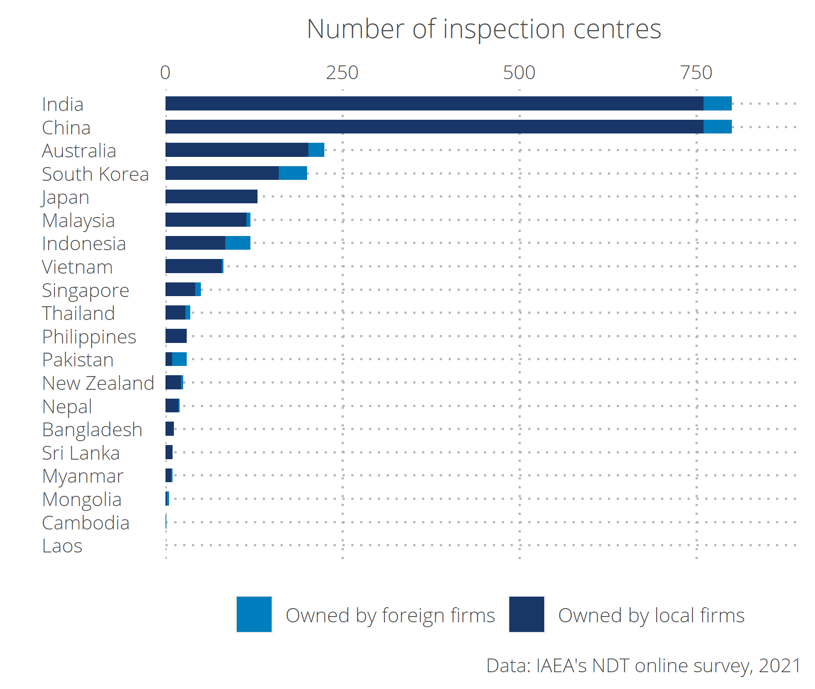

Figure 4: Number of inspection centres by type of ownership and country

Figure 5 below shows the number of **training centres** own by local and foreign firms in each RCA country.

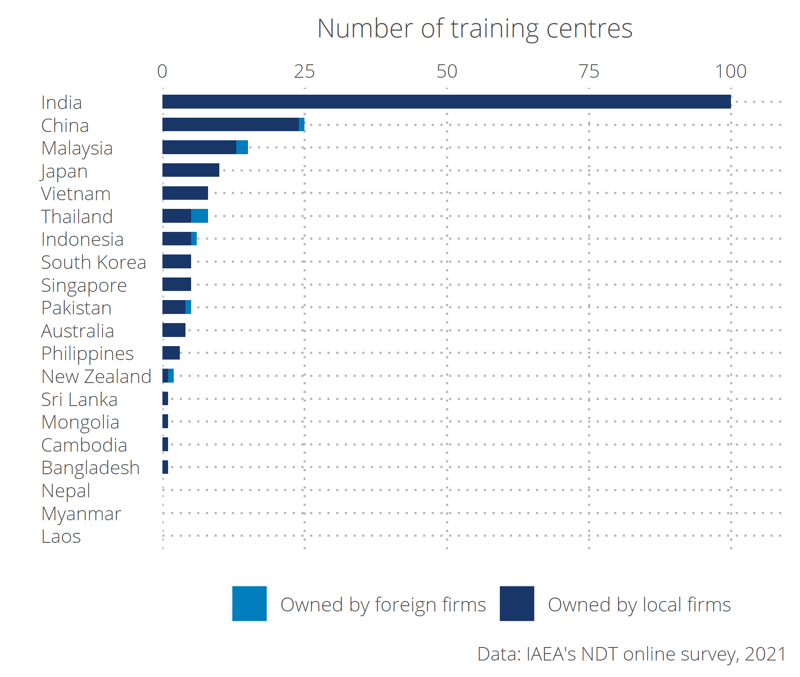

Figure 5: Number of inspection centres by type of ownership and country

### Contribution of RCA in the development of local inspection and training centers

According to the own perception of the GPs that participated in the online survey, **the RCA NDT programme has contributed to a great extent in the establishment of inspection centres in Other of the 22 countries that are part of the programme** (); in Other countries RCA has facilitated the investment in local investment centres; And, Other countries perceived that RCA has contributed to a great extent in the establishment of local training centres (See Table 2)

Table 2: Contribution of RCA programme to the establishment of local inspection and training companies.

|  |  |  |  |  |  |  |
| --- | --- | --- | --- | --- | --- | --- |
| Country | Has local inspection companies | RCA contribution to establish local inspection centres | RCA contributed to facilitate investment in inspection centres | Has local training centres | RCA contribution to establish local training centres | RCA standard |
| Australia | Yes | Not at all | No | Yes | Not at all | Excellent |
| Bangladesh | Yes | To a great extent | Yes | Yes | To a great extent | Good |
| Cambodia | No | Not at all | No | Yes | Little | Good |
| China | Yes | To a great extent | Yes | Yes | To a great extent | Good |
| India | Yes | Little | Yes | Yes | Not at all | Good |
| Indonesia | Yes | To a great extent | Yes | Yes | To a great extent | Good |
| Japan | Yes | Not at all | No | Yes | Not at all | Good |
| Laos | No |  | No | No |  | Inadequate |
| Malaysia | Yes | To a great extent | Yes | Yes | To a great extent | Excellent |
| Mongolia | Yes | Little | No | Yes |  | Good |
| Myanmar | Yes | Little | No | No |  | Inadequate |
| Nepal | Yes | Little | No | No |  | Inadequate |
| New Zealand | Yes | Not at all | No | Yes | To a great extent | Good |
| Pakistan | Yes | To a great extent | Yes | Yes | To a great extent | Excellent |
| Philippines | Yes | To a great extent | Yes | Yes | To a great extent | Good |
| Singapore | Yes | To a great extent | Yes | Yes | To a great extent | Excellent |
| South Korea | Yes | To a great extent | Yes | Yes | To a great extent | Excellent |
| Sri Lanka | Yes | Little | No | Yes | To a great extent | Good |
| Thailand | Yes | Not at all | No | Yes | Little | Good |
| Vietnam | Yes | To a great extent | Yes | Yes | To a great extent | Excellent |

## Certified personnel

This section introduces the findings on the extent in wich the support in establishing GPs’ NDT infrastructure through the RCA programme has enabled GPs to produce certified personnel in advanced techniques (RT-D, PAUT, TOFD, PEC, etc), in addition to the conventional methods (RT, UT, MT, PT, ET).

## Increased scope and scale of NDT demand and use

### Awareness, interest, and application

### Research & Development

## Improved health and safety

## Economic value (Aaron)

# Conclusion

# Annex: Case studies

# Annex B: Survey Analysis

## Introduction

X GPs are part of the agreement, findings include analysis of data collected from X experts.

Add Description of how the standards and criterion were define

## Criterion 1: **Improved NDT capacity and capability**

Brief description of relevance and background of this criteria **Julian**

Table 2: Table 1: Key evidence for criterion 1

|  |  |  |  |  |  |  |  |  |
| --- | --- | --- | --- | --- | --- | --- | --- | --- |
| Varname | Evidence | Dimension | Standard | Source | Question | Comments | AS comment | JK comment |
|  | ** Official infrastructure ** |  |  |  |  |  |  |  |
| cert_schm | %GP% with a National Certification Scheme on NDT | Official infrastructure | Adequate | Online survey | Has %GP% established a national NDT Certification Scheme? |  |  |  |
| cert_schm_lkrt | %GP% claims that the RCA NDT programme contributed to the establishment of the National Certification Scheme on NDT | Official infrastructure | Adequate | Online survey | In your opinion, to what extent did the RCA NDT programme contribute to the establishment of the NDT Certification Scheme in %GP%? To a great extent / Little / Not at all |  |  |  |
| cert_ncb | %GP% with a established national NDT Certification Body (NCB) on NDT | Official infrastructure | Good | Online survey | Has %country% established a national NDT Certification Body (NCB)? |  |  |  |
| cert_ncb_ICNDT | %GP% with NCB which has been accepted for registration under ICNDT MRA | Official infrastructure | Excellent | Online survey | If NCB, Has the NCB been accepted for registration by the ICNDT under the MRA? |  |  |  |
| cert_ncb_iso17024 | %GP% with NCB which has been accredited to ISO 17024 | Official infrastructure | Excellent | Online survey | If NCB, Is the NCB offering ISO 9712 certification? Is it accredited to ISO 17024? |  |  |  |
| cert_body_lkrt | %GP% claims that the RCA NDT programme contributed to the establishment of the national NCB | Official infrastructure | Good | Online survey | In your opinion, to what extent did the RCA NDT programme contribute to the establishment of the NDT National Certification Body (NCB) in %GP%? |  |  |  |
| cert_society | %GP% with NDT Society established | Official infrastructure | Good | Online survey | Has the NDT Society been established in %country%? |  |  |  |
| cert_society_year |  |  | Good | Online survey | Please state the year when the NDT Society was established in %country%? |  |  |  |
| cert_society_mems |  |  | Good | Online survey | How many registered members does your NDT Society have? |  |  |  |
| cert_society_ICNDT | %GP% with NDT Society which is a signatory to ICNDT MRA | Official infrastructure | Excellent | Online survey | Is the NDT Society a signatory to the ICNDT MRA? |  |  |  |
| cert_society_APPFNDT | %GP% with NDT Society which is registered with APFNDT | Official infrastructure | Excellent | Online survey | Is the NDT Society a registered member of the Asia Pacific Federation of NDT (APFNDT)? |  |  |  |
|  | %GP% with NDT Society which is registered with APFNDT and ICNDT | Official infrastructure | Excellent | Online survey | We will use the combination of the above two questions. |  |  |  |
| cert_society_role | %GPs% with NDT societies playing a relevant role to flourish the NDT technology in its country | Official infrastructure | Excellent | Online survey | What are the role(s) of the NDT Society which contribute to promoting the uptake of NDT technology in %country%? List of roles is: |  |  |  |

Promote the establishment and acceptance of national NDT certification scheme at the national level Promote the establishment of the NCB, training centres, inspection companies, for a sustainable NDT infrastructure in the country Provide representatives in strategic national committees to uphold and protect the interests of NDT stakeholders Promote the recognition and acceptance of NDT certificates issued by the NCB at the international level through ICNDT MRA Advance scientific, engineering, and technical knowledge in the field of NDT through education, research, seminar, workshop, forum etc. Enhance technical and administrative awareness among decisionmakers and stakeholders on the progress and way forward of NDT at the global level |Do we want it single select or multiple select? |The wording of this question is very complicated, will people who are not fluent in english be able to understand it? Have rephrased |Multiple select, I think OK | |cert_society_lkrt |%GP% claims that the RCA NDT programme contributed to the establishment of the NDT Society |Official infrastructure |Good |Online survey |In your opinion, to what extent did the RCA NDT programme contribute to the establishment of the NDT Society in %GP%? | | | | | |** Inspection companies and training centres ** | | | | | | | | | |%GP% has inspection companies owned by foreign entities |Inspection companies and training centres |Adequate |Online survey |Approximately, how many NDT inspection companies are there in %country%? | | | | | |%GP% has local inspection companies |Inspection companies and training centres |Good |Online survey |Approximately, how many of these %insp_services% NDT inspection companies are local (not foreign) companies? | | | | | |%GP% has local inspection companies which provided services abroad |Inspection companies and training centres |Excellent |Online survey |Has any of the %insp_services_local% local NDT inspection companies provided its services abroad? | | | | | |%GP% claims that the RCA NDT programme contributed to the establishment of local inspection companies |Inspection companies and training centres |Good |Online survey |In your opinion, how much has the RCA NDT programme contributed to the establishment of these local inspection companies in %country%? | | | | | | |Inspection companies and training centres | | |Approximately, what was the estimated total revenues of NDT inspection companies in 2000 and 2020 in local currency %currency%? | | | | | | |Inspection companies and training centres | | |Approximately, what is the average net profit of NDT inspection companies as a proportion of revenues in %country%? Less than 5% of revenue…1 Between 5 - 10% of revenue…2 Between 10 - 15% of revenue…3 Between 15 - 20% of revenue…4 More than 20%…5 | | | | | | |Inspection companies and training centres | | |Approximately, what is the average number of NDT inspections carried out by each licensed NDT inspector per year? | | | | | | |Inspection companies and training centres | | |What is the overall average price charged for one NDT inspection carried out by a licensed inspector of a private sector NDT inspection company in local currency?  | | | | | |%GP% has NDT training centres owned by foreign entities |Inspection companies and training centres |Adequate |Online survey |How many NDT training centres are operating in %country%? | | | | | |%GP% has local NDT training centres |Inspection companies and training centres |Good |Online survey |How many of the %traincen% NDT training centres are local (not foreign) centres? | | | | | |%GP% has local training centres which provided training abroad |Inspection companies and training centres |Excellent |Online survey |Has any of the %traincen_locall% local NDT training centres provided training activities abroad? | | | | | |%GP% has local NDT training centres offering ISO 9712 training |Inspection companies and training centres |Good |Online survey |How many of the %traincen_local% local NDT training centers are offering ISO 9712 certification? | | | | | |%GP% has local NDT training centres accredited under the national NDT Certification Scheme |Inspection companies and training centres |Excellent |Online survey |How many of the %traincen_local% local NDT training centres are Accredited Training Centres under the national NDT Certification Scheme? |Removed | | | | |%GP% has local NDT training centres accredited by the NCB |Inspection companies and training centres |Excellent |Online survey |How many of the %traincen_local% local NDT training centres are Accredited Training Centres by the NCB? |Removed | | | | |%GP% claims that the RCA NDT programme contributed to the establishment of local NDT training centres |Inspection companies and training centres |Good |Online survey |In your opinion, how much has the RCA NDT programme contributed to the establishment of these local NDT training centres in %country%? | | | | | |** Certified personnel ** [ONLY FOR THOSE WHO HAVE LOCAL ACCREDITED NDT TRAINING CENTRES] | | | | | | | | | |Number of organisation-level personnel certified on each NDT method by local accredited centres under the RCA NDT programme per year, since 2000 |Trained personnel |Adequate |Online survey |What is the average number of organisation personnel certified on %train_advanced% by local NDT Accredited Training Centres under the RCA NDT programme, per year, since 2000? | | | | | |Personnel has been certified by local accredited NDT training centres in some of the five conventional methods (RT, UT, MT, PT, ET) |Trained personnel |Adequate |Online survey |From previous question | | | | | |Personnel has been certified by local accredited NDT training centres in all of the five conventional methods (RT, UT, MT, PT, ET) |Trained personnel |Good |Online survey |From previous question | | | | | |Personnel has been certified by local accredited NDT training centres in advanced techniques (RT-D, PAUT, TOFD, PEC, etc) in addition to the conventional methods (RT, UT, MT, PT, ET) |Trained personnel |Excellent |Online survey |From previous question | | | |

## Criterion 2: **Increased scope and scale of NDT demand and use**

Note: Remember to include a note saying that all the indicators refer to the result of having participated in the RCA programme of IAEA.

Table 2: Table 1: Key evidence for criterion 2

|  |  |  |  |  |  |  |  |
| --- | --- | --- | --- | --- | --- | --- | --- |
| Evidence | Dimension | Standard | Source | Question | Comments | AS comment | JK comment |
| ** Awareness, interest, and application ** |  |  |  |  |  |  |  |
| %GP% has initiated activities to create awareness among industrial organisations about the benefits of NDT technology for QA and QC | Awareness, interest, and application | Adequate | Online survey | Has %country% taken any step to create awareness among industrial organisations about the benefits of NDT technology for Quality Assurance and Quality Control? |  |  |  |
|  | Awareness, interest, and application | Adequate | Online survey | Which steps have been taken to create awareness? List of steps is: |  |  |  |

Stakeholders engagement through seminars, workshops and/or forums Engagement with policymakers and regulatory body(s) Technological talks to university and college lecturers and students Other |Multiple select | | | |RCA NDT programme has contributed to increase the concern/ interest about applying NDT technologies for Quality Assurance and Quality Control in the industrial sector in %country% |Awareness, interest, and application |Good |Online survey |To what extent has being part of the RCA NDT programme contributed to increase the concern/ interest about applying NDT technologies for Quality Assurance and Quality Control in the industrial sector in %country%? | | | | |%GP% started applying NDT technology for the QA and QC among industrial companies |Awareness, interest, and application |Good |Online survey |Has any NDT technology been applied for the Quality Assurance and Quality Control in any of the following industrial sectors in %country%? The list of sectors is the following: Oil and gas………………………..1 Power generation (excluding nuclear)…2 Petrochemical………………………3 Chemical…………………………..4 Aerospace………………………….5 Manufacturing………………………6 Railway……………………………7 Nuclear……………………………8 Construction……………………….9 Shipping…………………………..10Other…………………………..96 |Yes/no for each industrial sector | |In case there are any other significant categories not on the list, should we give them an “other - please specify” option? Done. Also, is there some way we can get a sense of the level adoption of NDT technology for QA/QC - e.g. A few early adopters, becoming widespread, well-embedded in business as usual? Added a question just below. | | |Awareness, interest, and application |Good |Online survey |In your opinion, what is the level of NDT technology for the QA and QC among industrail companies in %country%? | | | | |Through the application of NDT technology in the industrial sector, %GP% has achieved at least one of the following benefits: 1) controlled manufacturing, 2) lower production costs, 3) ensuring material quality, 4) greater product integrity. |Awareness, interest, and application |Excellent |Online survey |Has the introduction of NDT technology in the %productivity% industry caused positive improvements in any of the following dimensions between 2000 and 2020? The list of dimensions is the following: Controlled manufacturing….1 Lower production costs……2 Ensuring material quality…3 Greater product integrity…4 |Yes/no for each industrial sector |Can we clarify what time period for productivity improvements we are asking about? Added specification. My main question here is that we are asking about each of these dimensions PER INDUSTRY, which makes this quite long, specially now that we added the follow-up question on the proportion of costs reduced because of NDT introduction.Given that ultimately these 4 categories are actually dimensions of productivity themselves, can we at least eliminate the following two questions about productivity in general? |At the risk of making it more complicated, we might also need to get some sense of magnitude of the productivity improvements. Will you need this Aaron? | | |Awareness, interest, and application | |Online survey |Approximately, what is the percentage by which production costs are lower due to the introduction of NDT in the %productivity% industry between 2000 and 2020? Small decrease (1% decrease) / Moderate decrease (5% decrease) / Significant decrease (10% decrease or more) | | | | | |Awareness, interest, and application |Excellent |Online survey |Approximately, what was the average inspection productivity (in time to conduct an inspection) in 2000 in the industrial sector in %country%? |Do we really want to keep this one? It is confusing |It would be useful to know if productivity has changed between 2000 and 2020 and if any of that change is caused by the RCA. I don’t think we need to break it down by industry | | | |Awareness, interest, and application |Excellent |Online survey |Approximately, what was the average inspection productivity (in time to conduct an inspection) in 2020 in the industrial sector in %country%? |Do we really want to keep this one? It is confusing | | | |** RD ** | | | | | | | | |%GP% has successfully trained personnel in the NDT technology as a result of being part of the RCA NDT programme. |R&D |Adequate |Online survey | |Help here. What is the difference between this indicator and the certifications in row 30 under Criterion 1? | |Good thing to check with experts. I’m not sure if it’s the same or different. The difference might be training of public sector scientists who oversee the NDT in criterion 1 vs takeup by industry in criterion 2? This is only a wild guess. OK. I guess we will get to know when they test the questionnaire. | |%GP% has established R&D activities on NDT technology |R&D |Good |Online survey |Has %country% established any R&D activities related to NDT? | | | | | |R&D | |Online survey |To what extent have the trainings from the RCA NDT programme enabled or promoted the initiation of R&D activities related to NDT in %country%? | | | | |Number of NDT publications developed anually under the RCA NDT programme |R&D |Excellent |Online survey |On average, how many publications related to NDT have been published annually since 2000 in %country% as a result of being part of the RCA NDT programme? | | | | |Number of NDT seminars/conferences developed anually under the RCA NDT programme |R&D |Excellent |Online survey |On average, how many seminars/conferences related to NDT have been organised annually since 2000 in %country% as a result of being part of the RCA NDT programme? | | | | | |R&D |Excellent |Online survey |What are the institutions with whom RCA NDT trainees share the outputs (publications, invitations to seminars/conferences) of the R&D activities related to NDT? The list of institutions is the following: Plant/asset owners……….1 NDT inspection companies….2 NDT equipment suppliers…..3 Universities…………….4 Other research institutes…5 Other…………………..96 | | | |

## Criterion 3: **Improved health and safety**

[Brief description of relevance and background of this criteria] *Julian

# Annex C: Economic Analysis

# Annex D: Theory of Change

# Annex E: Criteria and standards

# Work cited